Non-Recourse Loan Docs
Income
- None – DSCR
REO
- Current mortgage statements for all properties owned.
- If taxes and insurance are not escrowed on the mortgage statement(s), current tax bill and insurance dec page with premium amount is required.
- If applicable, current HOA statement with property address, HOA information, and the amount & frequency of the dues.
401K
- 401K formation/adoption docs.
- 401K plan summary.
- 401K liquidation check or wire receipt and any paperwork involved if fees are taken out for initial setup. The deposit into the 401K account must match the funds withdrawn from the 401K. Example of potential fees from the setup process:
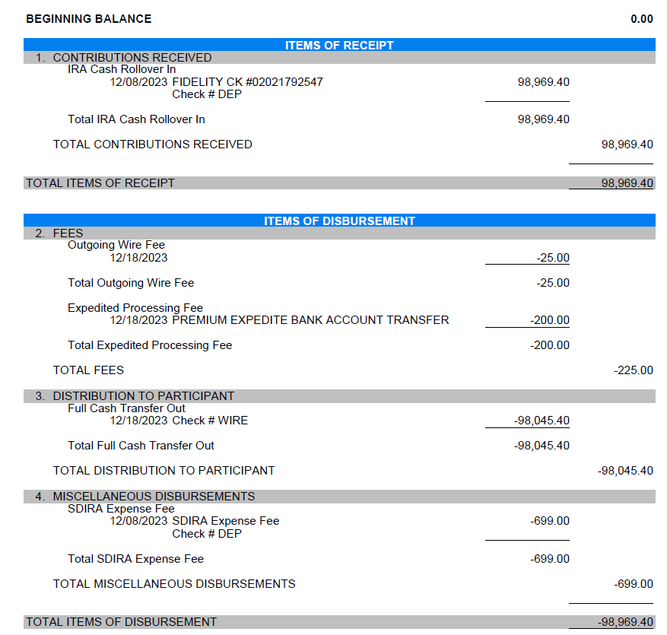
LLC
- LLC formation docs – Articles of Incorporation or Certificate of Formation.
- LLC Operating Agreement – must include the percentage(s) of ownership.
- Documented evidence of the federal EIN.

Assets
- 401K account agreement.
- 401K bank statement encompassing at least 30 days, all pages including blanks.
- Any other bank statements from where funds to close will be pulled, including EMD funds. Again, all pages including blanks.
Credit
- Physical credit report and credit invoice must be submitted to the lender.

***Title and insurance must be ordered in the name of the entity in which the loan is closing***

